**Knox Makers Serpenski Triangle**

**Intro to SMT Soldering Kit Instructions**

Surface mount technology uses physically small components that allow for smaller assemblies, higher performance circuits, access to modern integrated circuits and cool factor among your maker friends. Thru-hole component technology was enough to put us on the moon but relatively few modern integrated circuits are offered in thru-hole technology. Surface Mount Devices (SMD) open up a wide array of possibilities to the electronics enthusiast.

**Intro to Surface Mount Soldering**

**Surface mount soldering irons**

To solder these smaller components, a soldering iron where temperature can be set in degrees (not just a vague number like 1-10) is highly desirable and fine point replaceable tips are pretty much a must for anything other than occasional soldering of the largest SMT parts. A common rule of thumb is that the tip of the soldering iron should be of similar size as the pad of the component you are soldering. From a practical perspective a 1/16” to 1/8” tip can handle a wide range of SMT components.

**Surface mount solder**

There are strong opinions out there when it comes to “what solder should I use”, much like asking car guys which oil is best. Truly, it doesn’t matter, they all work. Use something designated for electronics, not plumbing. Now, some details, and remember, don’t overthink this, just go solder.

A small diameter SnPb wire solder is recommended. 0.015” will work well with a wide range of SMT components. 0.03” to 0.04” can be used with larger components but can be difficult to get nice looking results.

Lead (Pb) or lead-free (Pb-free) solder? Both perform equally well. Most people find lead-free easier to use, though with practice they are fairly close to each other. Much of what you read on the internet may be tainted by experiences from when lead-free solder was first developed. Metallurgy has progressed since then and lead-free solders are easier to use now. That said, most folks recommend solder with Pb to start.

People are often concerned with Pb exposure when soldering. The most likely internal exposure to Pb is ingestion due to your hands becoming contaminated from handling solder, from dust, and from “dross”- fine particles of Pb that can be generated while soldering and then end up on the hands. If you then chew your fingernails or eat food without washing your hands, you can ingest Pb. Fumes are not a concern for the home enthusiast using proper soldering temperature. Solder work is typically performed at less than 750°F while Pb fumes are generated in significant quantities at temperatures closer to 840°C. So, keep your temperatures where they should be and wash your hands.

Solder includes a flux core in the middle of it. This flux generates the smoke you see when people are soldering and it can be a lung irritant to some people. If you solder daily or find it irritating then a fan or fume extractor might be a good investment though many never find it necessary.

**Soldering Temperature**

Temperature settings vary based on the particular solder iron, the tip used, the component being soldered, the PCB layout being soldered to and technique. Generally speaking, lower temperature is preferred to higher temperature and faster soldering times are preferred to slower ones. The main reason for this is to minimize how much heat is transferred to the device being soldered and to the pads and traces on the PCB itself. Overheating the component can melt internal plastics (e.g. switches and jacks) and can even damage components like integrated circuits. 10 seconds of heat is fine, 30 seconds is probably fine, but don’t push it. Overheating or repeated heating of PCB pads and traces can cause them to delaminate, lifting off the PCB. Reheating a pad 5 to 7 times is probably fine. Play with your temperature setting to find what gives you a nice result with minimum soldering time. 750°F is a good starting point. 730°F to 760°F is common but those are loose numbers, use what works for you and don’t worry about it too much though 800°F is getting pretty hot. Lead-free soldering tends to need slightly higher temperatures than Pb solder.

Fine point tweezers are a must have. They don’t need to be expensive, and be careful with them. One drop on their tips will bend them, likely beyond good repair.

The last thing you probably need is some type of optical magnification. 3x to 7x is a good range to be in. 3x can be too little for some people or for smaller components but 7x can also feel cramped with visor magnifiers due to their short working distance. Focal distance or working distance refers to the distance between the lens and the workpiece. 4” can feel cramped, 8” is very comfortable. You get what you pay for with optics. Very good visor magnifiers (a la Donegan OptiVisor can be had for around $50). Some prefer digital microscopes (digital cameras on a stand) which can be < $100. Low magnification lamps are only good enough for those with great eyesight or the largest SMT components. An optical microscope can be very nice but new can cost $400--$500.

Small solder braid can be helpful for cleaning up joints.

**Handling SMT components**

SMT components typically come in cut tape form or in small containers. When pulling tape and removing components, it’s easy to accidentally shoot the part across the desk, onto the floor, never to be found again. Work slowly and be careful.

When placing a component with tweezers, it’s easy for the component to shoot out of the tweezers, across the desk, onto the floor, never to be found again. This is likely to happen now and again, no matter how long you’ve done SMT soldering. Some components, like resistors, are usually easier to handle due to their having nicely squared edges. Capacitors and diodes usually have more rounded edges and quite easily fly out from between tweezer tips.

**Soldering technique**

There are multiple ways to solder SMT components. A typical SMT resistor or capacitor is soldered by first putting a small bump of solder on one of the PCB pads and then reheating that bump of solder while pushing the SMT component into the wet solder and against the solder iron tip until the solder flows nicely along the component. Ideally this results in a nice, clean fillet between the component and the pad. Then the other side is soldered. Finally, the first pad is sometimes reflowed a second time to clean up the joint.

If solder doesn’t want to flow, a bit of flux from a flux pen or other dispenser may do the trick.

Watch some online videos for some good demonstrations.

**Start with the practice PCB**

In this kit you’ll find a separately bagged practice PCB with components, shown in Figure 1. Put the rest of the kit aside and start with this practice PCB.

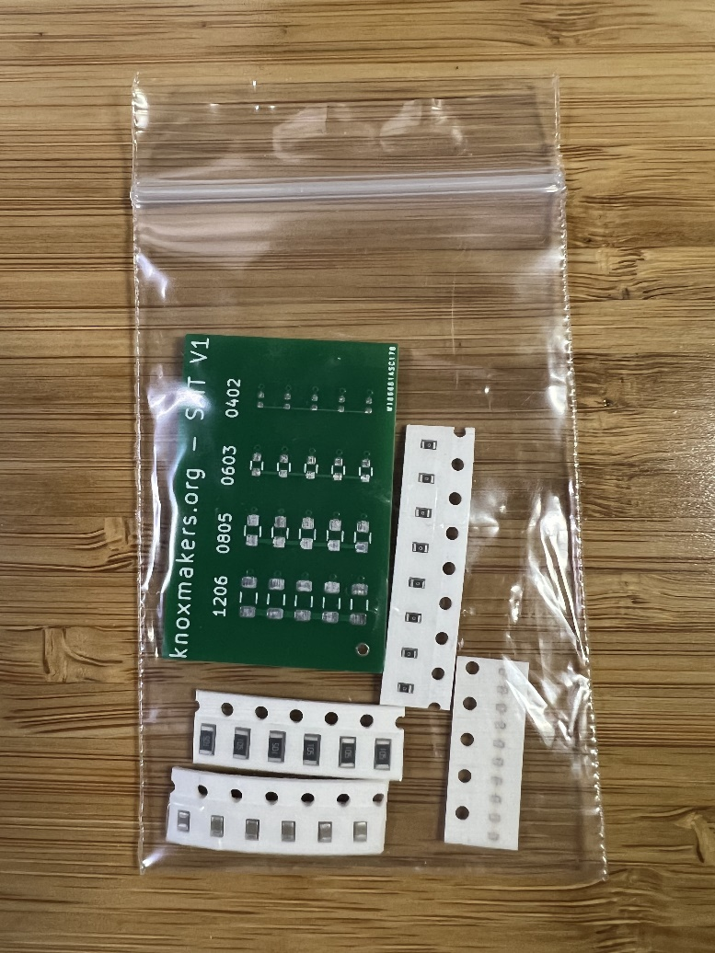

**Figure 1: Resistor Locations**

Figure 2 identifies the size of the components included. Many SMT parts have size designators such as “1206” or “0805” which notes the length and width of the part. “1206” means 120mil x 60mil. “0805” means 80mil x 50mil. Most people who are starting to learn SMT soldering, but have good equipment, find 1206 components straightforward, 0805 not bad, 0603 challenging, and 0402 quite difficult. The end kit we are building uses 1206 and 0805 components but give the smaller parts a try as well.

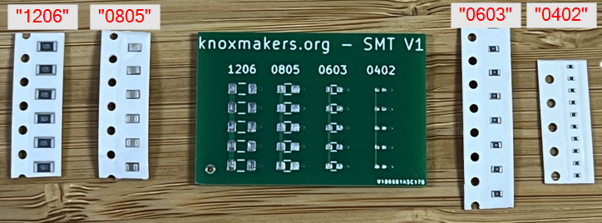

**Figure 2: Component Sizes**

**Now Let’s Build the Kit**

**Start with the fixed resistors (Figure 3)**

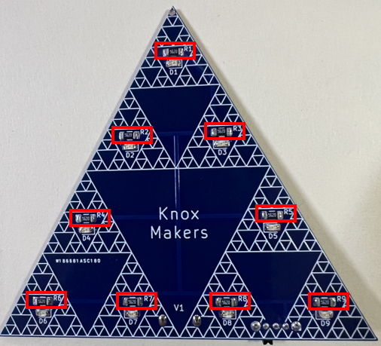

**Figure 3: Resistor R1-R9 Locations**

The resistors are of 1206 size, the larger of the two SMT components in the kit. They have no polarity and can be soldered in any orientation. These are large enough to usually have labels on them to describe their resistance. The image and table below show examples. AA is the ohms prefix, B is the number of zeros after it. Use whichever value is included in the kit and solder them into locations R1-R9.

AAB

|  |  |
| --- | --- |
| **Marking** | **Value** |
| 102 | 1,000 Ω or 1 kΩ |
| 103 | 10,000 Ω or 10 kΩ |
| 220 | 22Ω |
| 1R0 | 1.0Ω |

**Figure 4: Example Resistor Value Designator**

**Now the LEDs (Figure 5)**

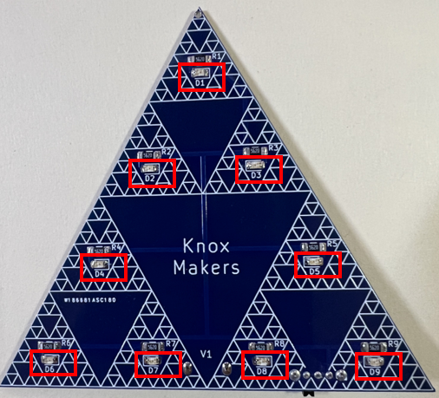

**Figure 5: LED D1-D9 Locations**

The other SMT component in this kit is a light emitting diode (LED). This part does have polarity and must be oriented as shown in Figure 6. If soldered in backwards, that LED will not light, though the rest will work fine. Figure 6 shows a mounted diode on top and underneath shows a second diode in the same orientation, flipped to expose the back. Various diodes have different markings for orientation and some diodes are enclosed in more opaque materials, so the internal structures may not be visible. Use the green markings circled in Figure 6 and orient them relative to the partial rectangle in silkscreen on the PCB. Note that the left side of the PCB has the diodes flipped compared to the right side.

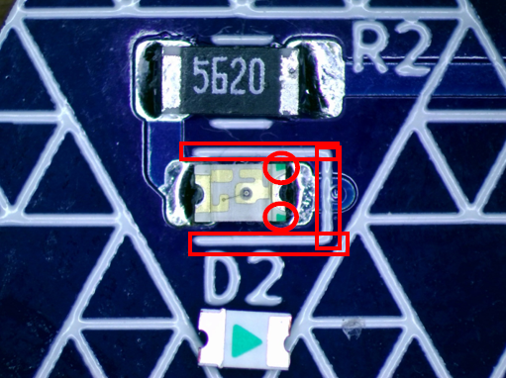

**Figure 6: LED Orientation**

**USB Power Jack (Figure 7)**

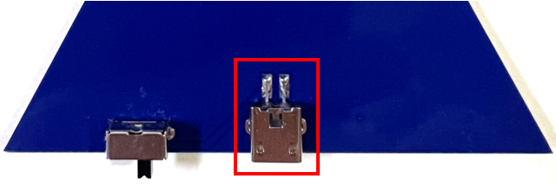

**Figure 7: USB Power Jack**

The small pins on the power jack can be fragile so handle them with care. First insert the power jack into the through-holes and solder in place from the front of the PCB, making sure to keep the jack flush with the PCB. Then solder the two pins to the SMT pads on the back side.

**Power Switch (Figure 8)**

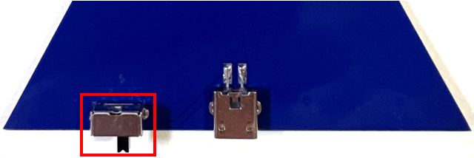

**Figure 8: Power Switch**

The last component is the through-hole power switch. Orient it as show and solder in place from the front side. Try to work quickly to avoid melting the plastic internal to the part itself.

**Turn it on!**

Plug it in and cycle the power switch to see the LEDs illuminate. Enjoy!

**Debugging**

If no LEDs are illuminating:

* Check that the power jack is soldered in place correctly. Reflow the solder joints to make sure they are making good contact
* Check that the switch is soldered well, reflowing joints to make sure they make contact.
* Try another USB power source.

If some, but not all LEDs are illuminating:

* Reflow the leads on the diode and the neighboring resistor
* Check the diode for proper orientation
* It’s possible, though unlikely, that the diode itself is damaged or bad. It can be removed with hot air reflow or with your solder iron by alternately heating each side of the LED until both sides are melted at the same time and it can be pushed aside.

**Theory of Operation**

Power enters the circuit via the USB jack and is then fed to the power switch. When the power switch is in the ON position, it completes a metal contact from the power feed of the USB jack to traces that connect to all of the resistors and diodes on the PCB.

The resistors limit the current that flows through the LEDs. Lower value resistors “resist” current flow less, so they allow more current and brighter LEDs. Higher value resistors result in dimmer LEDs. That’s pretty much it!

**Bill of Materials**

|  |  |
| --- | --- |
| **Designator** | **Item** |
|  | PCB |
| J1 | Jack, USB Micro |
| D1-D9 | LED, 0805, various colors |
| R1-R9 | Resistor, 1206, various values |
| S1 | Switch, SPDT, right angle |

**Schematic**

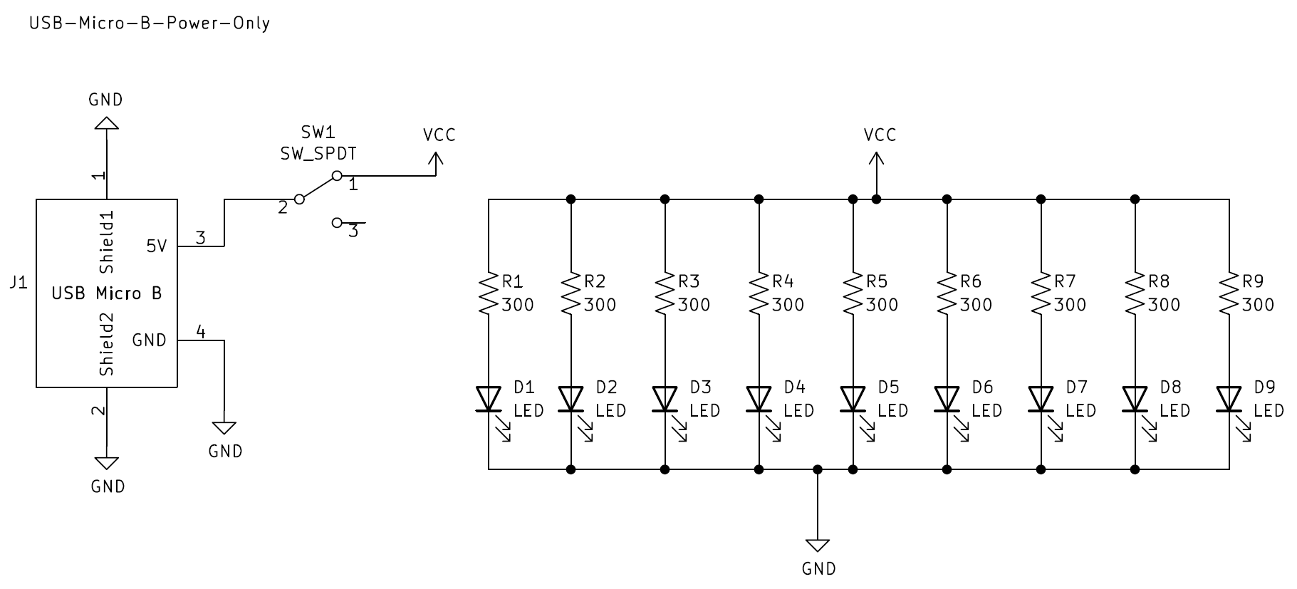

**PCB Layout**

